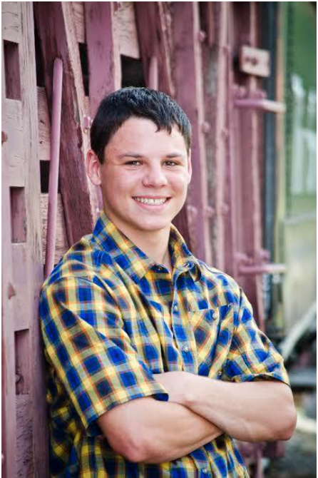
Andrew Miller, he/him
AmeriCorps Member
Andrew is originally from Wheat Ridge, Colorado. He attended the University of Wyoming and received a B.S. in Environmental Geology and Geohydrology in 2020. As an undergraduate at UW, he spent time researching the hydrothermal pools in Yellowstone. Through this research he developed a passion for Yellowstone and hopes to continue his research there when he begins graduate school in the Fall. Andrew wanted to pursue an Americorps position at TSS to engage with the community living on the doorstep of Yellowstone and to help educate people of all ages about a place he is deeply passionate about. In his free time, Andrew enjoys hiking, kayaking, and playing board games with friends.

