Martin C. Kitto
martinckitto7@gmail.com
NRSM 560 Final Paper

Wolves, Wilderness, and Chronic Wasting Disease (CWD): How Wolf Trophy Hunting Detracts from CWD Management and the Wilderness Act

Abstract

The absence of wolves from the majority of their historical range has contributed to an epidemic in cervids (members of the deer family) called Chronic Wasting Disease (CWD). CWD is reducing cervid populations in the United States and poses a risk to human health. The Greater Yellowstone Ecosystem (GYES), home to large tracts of wilderness, will be the first area in which the transmission cycle of CWD exposed to wolf predation can be studied. In order for the full effect of wolves on CWD to be observed, wolf trophy hunting within wilderness must end.

Introduction

In the continental United States, a native pathogen of wildlife is disrupting local economies and has the possibility of infecting humans (Gillin, Colin & Mawdsley, 2018). The ecological conditions under which Chronic Wasting Disease (CWD) has spread may not have been possible without the mass extermination of predators from North America in the 19th century (Wild, Hobbs, Graham, & Miller, 2011). The impact of large predators on the transmission cycle of CWD will be observed as the disease enters cervid populations in the Greater Yellowstone Ecosystem (GYES). Wolves have been implicated by scientists as having the hunting behavior most likely to suppress CWD (Krum, Conner, Hobbs, Hunter, & Miller, 2009; Wild et al., 2011). Thus far, human efforts relying on hunting or culling to lower CWD prevalence has not yielded demonstrable results (Gillin et al; Wild et al.).
In order for wolves to provide the ecological service of removing diseased animals from their prey population, they must not only be protected in Yellowstone National Park (YNP) but also in the surrounding wilderness areas. Federally designated wilderness was designed to conserve large tracts of land free from human exploitation (Dawson & Hendee, 2009). As the evidence continues to grow that top predators regulate the health of entire ecosystems, it should be reflected in wilderness management. This is especially relevant as CWD spreads into wilderness areas that have wolf populations capable of suppressing it.
Wolf trophy hunting is currently controlled by state wildlife agencies in Idaho, Wyoming, and Montana. While this may appease some local interest groups, it disrupts ecosystem functioning from the top-down and destroys the notion that wilderness ecosystems are free from human manipulation. The wolf trophy hunting season in Wyoming, regulated by the Wyoming Game and Fish Department (WGFD), occurs throughout wilderness areas in the northwestern portion of the state. Adjacent to YNP, these areas provide the habitat for ungulate herds that will become infected with CWD in the years to come. Small packs of wolves also call these wilderness areas home, but are limited in size and complexity by human intervention. Literature related to CWD and wolf ecology establishes the important role wolves can play in preventing the spread of this disease. In order to do this, their populations must be allowed to reach natural levels.

The Wilderness Act and Ecosystems
The Wilderness Act of 1964 was enacted to secure for present and future generations an enduring resource of wilderness. Section 2(c) of the Act defines wilderness as “an area where the earth and its community of life are untrammeled by man, where man himself is a visitor who does not remain.” An area of wilderness is further defined as “an area of undeveloped Federal land retaining its primeval character and influence, without permanent improvements or human habitation, which is protected and managed so as to preserve its natural conditions.” As stated in section 4(b), it is the responsibility of the federal agencies tasked with managing these areas to preserve their wilderness character.
An interagency team updated its recommendations for federal agencies tasked with wilderness management in Keeping It Wild 2 (Landres et al., 2015). They recommended that four distinct qualities of Wilderness Character be utilized: untrammeled, natural, undeveloped, and solitude or primitive and unconfined recreation. The qualities most relevant to the wolf trophy hunting seasons are “natural” and “untrammeled.” Natural refers to the extent that wilderness ecological systems are substantially free from the effects of modern civilization. The natural quality of wilderness encompasses all of its naturally occurring biophysical components. The untrammeled quality means being free from modern human direct control or manipulation. The management implications of these directives is for agencies to scrutinize their actions regarding control or interference with natural processes and choose restraint when possible.
The Ecological Services of Wolves
Mech (1970) describes wolves as the dominant native predator of the entire northern hemisphere. By the early 1920s, however, wolves were almost entirely gone from the lower 48 because of huge eradication efforts by European Americans. Having evolved in close connection to their prey species of choice, the large hoofed mammals, their absence has affected the ecological community and their prey species in ways just beginning to be understood. A brief review of some of these discoveries will demonstrate the value of a natural population of wolves on the natural and untrammeled qualities of wilderness character.
Elk. The most glaring aspect of this influence is the impact wolves have on the ungulates (hoofed mammals) they prey upon. Data from 5 elk populations over the course of 16 years since wolves were reintroduced into YNP has shown that elk alter patterns of vigilance, distribution, behavior, aggregation and foraging in the presence of wolves (Creel, Liley, & Winnie, 2007). Habitat selection and spatial distribution of elk post wolf reintroduction has been linked to a trophic cascade (a phenomena in which a predator affects the plants that their prey species consumes) affecting the composition, structure, and functioning of plant communities (Licht, Millspaugh, Kunkel, Kochanny, & Peterson, 2010). Alteration of behavior and population densities of other species also has had a profound influence on the food web.
Willows. A study reviewing willow trees pre and post wolf reintroduction to YNP concluded that they became heavily browsed after the eradication of wolves but now appear to be recovering (Ripple & Beschta, 2005). The subsequent alteration of willow and other riparian species (plant communities that live close to rivers and streams) has also been correlated to density and reduction of neotropical bird migrants in willow communities impacted by browsing (Berger, Bellis, & Johnson, 2001).
Beavers. Smith (2012), explains that beavers (another species that had been eradicated from YNP) have migrated and settled into the park due to ongoing willow recovery. In turn, this has led to beaver ponds providing habitat for insects, fish, amphibians, reptiles, small mammals, birds, and moose. Riparian species of plants also thrive in these ponds and have been supported by beaver populations.
Aspen. Klaptosky (2016), has been looking at the role of wolves on aspen recovery. Comparing aspen stem heights of sites from 1999 to 2012, it appears aspen stand recovery is benefitting from wolf reintroduction. Researchers also noted that 30 to 40 percent of the aspen plots are thriving since wolves were reintroduced (Painter et al., 2018). Aspen is an important species within the GYES for its contribution to biodiversity and the support it provides to a variety of plant associations (Hollenbeck and Ripple, 2008; Klaptosky).
Scavengers. Twelve different vertebrate species have been observed feeding on wolf kills, including weasels, foxes, coyotes, ravens, eagles, magpies, mountain bluebirds, grizzly and black bears (Smith, 2012). In the Pelican Valley of YNP grizzly bears appear to steal wolf kills after every successful hunt (Smith, et al., 2016). In Sweden, a study concluded that wolves influence the distribution and availability of biomass through their kill sites, which may lead to an increase in survival and reproductive success of scavengers within wolf territories (Wikenros, Sand, Ahlqvist, & Liberg, 2013). This benefit is not possible without wolves, who are the only large predator to leave carcasses in the open and across the landscape for the entire year (Smith).
Other studies. In Canada, a study from Banff National Park found similar effects of wolves on aspen, willows, and birds just like the ones in YNP (Hebblewhite et al., 2005). A continent wide shift in coyote and red fox densities (wolves kill coyotes and coyotes kill foxes) due to competition from wolves has been suggested by Newsome and Ripple (2014). The wide range of ecological changes, from populations of other predators to the amount of nutrients found in the soil, demonstrate that a fully intact ecosystem in the GYES requires a fully intact wolf population.

CWD Overview
Careful review of the literature related to the CWD endemic shows that wolves can provide a public health benefit to humans. Hedlin, Taschuk, Potter, Griebel, & Napper, (2012) describes CWD as the most contagious of a family of diseases known as transmissible spongiform encephalopathies (TSEs). Unlike traditional pathogens that originate from bacterial, viral, or fungal sources, TSEs are caused by an infectious form of a prion protein. Prion proteins are found within all mammals but their biological role is still unknown. What separates an infectious prion from a healthy one is its shape. When an infectious prion comes in contact with a functioning one, it causes the healthy prion to copy its configuration. When this occurs in the Central Nervous System (CNS), “good” prions are changed into the “bad” form. This process kills off cells and eventually leaves the brain full of holes resembling a sponge in appearance. TSEs are transmissible and fatal in 100% of cases (regardless of species) with no effective treatment available.
Prion diseases gained notoriety during the bovine spongiform encephalopathy (BSE or Mad Cow Disease) outbreak of the 1980s. Other notable prion diseases include Creutzfeldt-Jacob Disease (CJD) in humans and scrapie in goats and sheep. These diseases all share a common mechanism, but they display species-specific differences in symptoms, pathology and transmissibility. In most TSEs the infectious prions are localized in the CNS, making reducing transmission relatively easy once the disease is discovered. The Center for Infectious Disease Research and Policy (CIDRAP) describes containment of past TSE outbreaks as manageable once they were detected (Osterholm Anderson, Zabel, Scheftel, Moore, & Appleby, 2019). Best practices related to TSE diseases remove contaminated material from the food chain and the transmission cycle breaks. What distinguishes CWD from other TSEs is that the infectious prions are also found in the cervid's bodily fluids such as saliva, urine, and feces. The infectious agent is then leaked into the environment everytime these fluids are secreted.
Gillin et al. in a report for the Association of Fish and Wildlife Agencies (AFWA) on best management practices for CWD, explains that infectious prions shed in the environment remain contagious for years and even decades. Currently, effective means to decontaminate a large area with infectious prions doesn’t exist. Further complicating matters is the long incubation period from an animal acquiring the disease to showing clinical signs. This allows the infected host to spread the disease for 1 to 5 years before death. CWD prions are also capable of binding to certain soils and plants while remaining infectious, making transmission not dependent on contact between animals.
Osterholm et al., states that CWD was first recognized in captive mule deer in a Colorado research facility in 1967. In 1981, CWD was detected in a wild cervid and has since become an established disease in North America and is now found in 26 states, 3 Canadian provinces, as well as Finland, Norway, Sweden and South Korea. The continued geographic spread of the disease increases the frequency of exposure to CWD prions among cervids, humans, and other animal species.
Threat to Cervids
The AFWA report considers CWD as currently the largest threat to populations of cervids in North America (Gillin et al.). It can transmit horizontally (animal-to-animal) and vertically (parent-to-offspring) among cervid populations. Horizontal transmission occurs through ingestion of the infectious agent via contact between animals or the contaminated environment (soil, plants, etc.). In endemic areas where the disease has been established, the proportion of CWD infected animals continues to increase (Carlson, Hopkins, Nguyen, Richard, Walsh & Walter 2018; Gillin et al.). In heavily infected areas cervid populations are decreasing over time, the USGS documented a mule deer population decline in Wyoming of 21%. Elk tend to have lower prevalence rates than deer, but a study within a high density heard in Rocky Mountain National Park found CWD can decrease populations of elk as well (Hedlin et al., 2012). Simulation modeling studies have predicted a variety of outcomes for free-ranging cervids affected by CWD, from local population declines to extinction (Wild et al.).
Threat to Humans
Due to the ability of other TSEs to overcome species barriers and animal studies suggesting that CWD can potentially infect non-human primates, public health organizations advise that CWD positive cervids should not be consumed, even though no cases of human infections have currently been identified (Gillin et al.; Osterholm et al.). These prions have evolutionary properties, and while the exact mechanisms of this action is still unknown, it has been confirmed that even without the required nucleic acid for genetic mutations, CWD prions are still affected by natural selection pressures. This is evident in the multiple strains of CWD that continue to be discovered. The diversity of CWD strains increases the probability of deadlier outcomes amongst cervids and of new CWD strains capable of interspecies transmission (Morales, 2017).

. The Role of Wolves in CWD Suppression
Wild et al. (2011) points to the eradication of wolves from their historical range in the United States as likely playing a significant role in the current unnatural distribution and prevalence of CWD. The prolonged clinical course of the disease, along with its symptoms, makes CWD the type of infectious disease that predation can dramatically influence. Wolves will remove infected individuals, limiting the amount of time the disease can be shed into the environment and between animals.
In a review of documented wolf hunting behavior over the last several decades in North America, Mech, Smith & Macnulty (2015) say it is clear that the most important component driving wolf hunting behavior is the selection of prey. It is well documented that wolves generally kill the young, the old, the diseased, disabled, or poorly conditioned. On Isle Royale in Michigan, the location of longest study of a predator-prey system ever done, it was found that the majority of middle aged animals killed by wolves were all afflicted with diseases, depleted of fat in their bone marrow, or infested with tapeworms. In YNP, biologists have also noted lower fat content in prey that was unusual for the time of year (Metz et al., 2016).
Wolves are a consistently low-success hunter of a wide range of prey, day after day circulating their territories and testing potential victims looking for signs of weakness, killing far less animals than they encounter (MacNulty, Stahler & Smith, 2016; Mech et al., 2015; Smith, 2012). In YNP wolf hunting elk rarely exceeds 20% success, drops to less than 10% when considering adult elk, and is only 2% for a single wolf hunting alone (MacNulty et al.).
Mech (Zamenhof et al., 1971; Bresler et al., 1975; Chandra, 1975; 1991; Kaati et al., 2007 IN: Mech et al. 2015) and Mech (1970) describe that to overcome their deficiencies in hunting ability, evolution has allowed wolves to cooperate in packs, travel long distances, and identify subtle signs of weakness in their prey. Substandard senses of smell, sound, or sight, having fewer brain cells, or even being unusually small, are all documented conditions that predispose an animal to wolf predation. Even amongst the young of a prey species, which subsidize a large portion of wolves' diet in the spring, wolves select for disadvantaged individuals. Juvenile snowshoe hares and young ungulates preyed upon by wolves have all been shown to be smaller than average. Therefore, any claim by humans that a wolf-killed animal was in “prime condition” is untenable.
CWD Symptoms in Wolf Prey
After a long incubation period of several years, CWD positive cervids begin to show symptoms visible to the human-eye. Commonly observed are significant weight loss, ataxia (gait abnormality), hypersalivation, a wide based stance with lowered head, deterioration of motor function such as hearing, vision, and gut control, loss of wariness, and persistent walking (Gilch, 2020; Gillin et al., 2018; Hedlin et al., 2012). Obviously, these symptoms would predispose the infected individual to predators at this stage of the disease, but there are symptoms that appear much earlier. In captive facilities the early subtle behavioral changes are detectable only by caretakers familiar with the individual animal (Gilch). Considering wolves' ability to notice vulnerabilities in prey, it is extremely likely this will continue with CWD infected cervids.

Pack Dynamics
Any conclusions about the effects of wolves on a prey population is incomplete without considering wolf pack dynamics. Wolves are biologically limited in their hunting ability and in response have evolved complex social behavior to gain an advantage (Stahler, Smith, & MacNulty, 2016). Smith (2012) and Cassidy et al. (2016) explain wolf packs as generally consisting of a breeding male and female (the alpha pair), their offspring, their offspring's litter, and so on. These patterns fluctuate as some pack members gain maturity and strike off on their own (while some stay with their lineal pack their entire life), die from natural causes, and disintegrate under pressure from competing packs or the death of the alpha wolves.
Wolf packs can be divided into two different groups, one being “complex” and the other being “simple”. Simple packs are composed of a breeding pair along with their pups, while a complex pack also contains wolves born from previous years in addition to the current year's litter. In YNP, where wolves are protected, there can be animals in packs born four or five years before the current litter, thereby creating multigenerational groups. Protection of wolves in YNP allows for the fuller age structure and complex social organization of its packs, while those located in wilderness area outside YNP suffer high levels of human-caused mortality and are thereby mostly limited to simple packs (Smith, 2012; Smith, Stahler et al., 2016). In YNP wolf packs generally average 9.8 while the average wolf pack size in the Wolf Trophy Game Management Area (WTGMA) of Wyoming is closer to 5 (Cassidy et al., 2016; Mills and Gregory, 2018; Mills and Gregory, 2019).
Research on wolf pack dynamics have found that the numbers and age of wolves influence the survival of its members, its ability to defend territory, and ultimately the pack's persistence (Cassidy et al., 2016; Smith, 2012). Wolves are one of the few animals that are truly territorial, actively defending their territories from competitors and engaging in battles that often result in maiming or death. Wolf packs compete for territory that has access to critical resources, such as offspring rearing space, availability of prey, and separation from humans and roads (Cassidy et al., 2016; Stahler et al., 2016; Smith, 2012). Cassidy et al. and Smith, found that the two factors have been determined as the most important components in determining a pack's ability to establish and defend territory are the number of adult wolves in the pack and the age of pack members. Both of these factors are negatively influenced by wolf trophy hunting.

Effects of Trophy Hunting
The Wyoming Gray Wolf Monitoring and Management 2018-2019 annual reports (Mills and Gregory, 2018; Mills and Gregory, 2019) set the biological objective of 160 wolves in the WTGMA where wolves are managed as trophy game species. As shown in fig. 1, a considerable amount of the WTGMA is within designated wilderness, specifically the North Absaroka, Washakie, Teton, Bridger, Fitzpatrick, Gros Ventre, Winegar Hold, and Jedediah Smith Wilderness areas. In the rest of the state wolves are designated “predatory animals” and can be killed year round with no license required.
In 2018, the total number of wolves killed through legal hunting in the WTGMA was 39, 22.7% of the total wolf mortality for the year. It affected 64.5% of wolf packs and killed 19 adult animals. 2019 saw 25 wolves killed by legal hunting, which was 27.2% of the total mortality, with 62% of packs affected. An even distribution of juvenile, subadult, and adult animals were killed in 2019. The number of adult wolves killed is highlighted because of the influence older wolves have on the likelihood of their pack’s survival. The report affirms that the number of wolves, packs, breeding pairs, and average pack size were reduced primarily through human-caused mortality. In both 2018 and 2019, wolf populations showed a lower resilience to human-caused mortality than predicted.
As wolf packs lose adult members their natural behavior changes, including altered predation patterns (Wielgus & Peebles, 2014). Hunting also causes an additional loss of dependent offspring and may disintegrate packs completely (Brainered et al., 2008). This alteration in behavior leads to unintended consequences on the biotic community of the wilderness areas within the WTGMA. This is demonstrated by the wide array of profound changes that have taken place in YNP since wolves were reintroduced and are not subject to hunting.
Cervid Migrations and CWD
In 2014 wildlife researchers with the University of Wyoming (Figure 2 and Figure 4) released findings of the exact routes big-game species use to migrate between their winter and summer ranges. The research proves that federally designated wilderness areas near YNP act as vital habitat for elk, mule deer, moose, bighorn sheep and pronghorn antelope during these migrations. The Clarks Fork and Upper Shoshone mule deer herds and the Cody and Clarks Fork elk herds travel extensively through the North Absaroka, Washakie, and Teton Wilderness areas (Figures 2 and 3). The deer and elk CWD endemic area spread in Wyoming, established by the Sierra Club, is progressing directly into the migration corridors of these herds (Figure 3 and 5). These migration corridors through wilderness are also the home of wolf packs documented by the WGFD (Figure 6) that are targeted by the Wyoming wolf trophy hunting season (Figure 1).
Conclusion
Aldo Leopold, one of the founders of the wilderness movement wrote, “To keep every cog and wheel is the first precaution of intelligent tinkering” (Leopold, 1949). The truth held within this statement has been uncovered by scientific research since the book was published in 1949. Leopold was an advocate of maintaining wolves and other large carnivores on federal lands to prevent the damage caused by unnaturally large populations of ungulates (Ripple & Beschta, 2005). If the objective of the Wilderness Act is to protect natural processes from human domination, the question must be asked, how can this be accomplished without wolves? Parallel to this reasoning, the unimpeded spread of CWD throughout the United States and the likelihood of wolves positively impacting its prevalence, amplifies the importance of this species. The long held belief that wolves are competition, and that eliminating them provides an abundance of desired animals, is wrong. Ironically, wolves contribute to ensuring the sustainability of its prey. If CWD ever crosses the species barrier and infects humans, knowledge of how to naturally disrupt its transmission will be indispensable. To begin the process of ecosystem restoration that will allow for a full understanding of containing this disease, wolf trophy hunting in wilderness must end.

List of References
Berger, Stacey, Bellis, & Johnson (August 1, 2001). A Mammalian Predator-Prey Imbalance: Grizzly Bear and Wolf Extinction Affect Avian Neotropical Migrants. Ecological Applications. 11(4), 947-960.

Carlson, Hopkins, Nguyen, Richards, Walsh & Walter. (2018). Chronic wasting disease: Status, science, and management support by the U.S. Geological Survey. USGS science for a changing world. Open-file report 2017-1138.

Creel, Christianson, Liley, Winnie (2007). Predation risk affects reproductive physiology and demography of elk. Science, 315(5814), 960.

Dawson & Hendee (2009). Wilderness Management, 4th ed. Fulcrum Publishing, Golden, Colorado.

Gillin, Colin, & Mawdsley (2018). AFWA technical report on best management practices for surveillance, management and control of Chronic Wasting Disease. Association of Fish and Wildlife Agencies, Washington, D. C.

Hebblewhite, White, Nietvelt, McKenzie, Hurd, Fryxell, Bayley & Paquet. (August 1, 2005). Human activity mediates a trophic cascade caused by wolves. Ecology. Volume 86, issue 8. 2135-2144. https://doi.org/10.1890/04-1269

Hedlin, Taschuk, Potter, Griebel & Napper (2012). Detection and control of prion diseases in food animals. ISRN Veterinary Science, 2012. https://doi.org/10.5402/2012/254739

Hollenbeck & Ripple (2008). Aspen snag dynamics, cavity-nesting birds, and trophic cascades in Yellowstone’s northern range. Forest Ecology and Management, 255(3-4), 1095-1103. https://doi.org/10.1016/j.foreco.2007.10.016

Klaptosky(2016). The Plight of Aspen: Emerging as a Beneficiary of Wolf Restoration on Yellowstone’s Northern Range. Yellowstone Science: Celebrating 20 Years of Wolves, 24 (1) 65-69.

Landres, Barns, Boutcher, Devine, Dratch Lindholm, ...Simpson (2015). Keeping it wild 2: an updated interagency strategy to monitor trends in wilderness character across the National Wilderness Preservation System. U.S. Department of Agriculture, Gen. Tech. Rep. RMRS-GTR-340. 114.

Leopold (1949). A sand county almanac: And sketches here and there. Oxford University Press.

Licht, Millspaugh, Kunkel, Kochanny & Peterson (2010). BioScience, 60(2), 147-153.

MacNulty, Stahler & Smith (2016). Understanding the limits to wolf hunting ability. Yellowstone Science. Volume 24 Issue 1: Celebrating 20 Years of Wolves.

Mech (1970). The wolf: The ecology and behavior of an endangered species. University of Minnesota Press.

Mech, Smith & Macnulty (2015) Wolves on the hunt: The behavior of wolves hunting wild prey. The University of Chicago Press.

Metz, Smith, Stahler, Vucetich & Peterson (2016). Temporal variation in wolf predation dynamics in Yellowstone: Lessons learned from two decades of research. Yellowstone Science: Celebrating 20 Years of Wolves. (24)1, 55-60.

Mills & Gregory (2019). Wyoming Gray Wolf Monitoring and Management 2018 Annual Report. Wyoming Game and Fish Department, U.S. Fish and Wildlife Service, National Park Service, USDA-APHIS-Wildlife Services, and Eastern Shoshone and Northern Arapahoe Tribal Fish and Game Department.

Mills & Gregory (2020). Wyoming Gray Wolf Monitoring and Management 2019 Annual Report. Wyoming Game and Fish Department, U.S. Fish and Wildlife Service, National Park Service, USDA-APHIS-Wildlife Services, and Eastern Shoshone and Northern Arapahoe Tribal Fish and Game Department.

Morales (2017). Prion strains in mammals: Different conformations leading to disease. PLoS Pathog, 13(7). https://doi.org/10.1371/journal.ppat.1006323

Newsome & Ripple (June 14, 2014). A continental scale trophic cascade from wolves through coyotes to foxes. Journal of Animal Ecology. 84(1). 49-59. https://doi.org/10.1111/1365-2656.12258

Osterholm, Anderson, Zabel, Scheftel, Moore, & Appleby (2019). Chronic wasting disease in cervids: implications for prion transmission to humans and other animal species. MBio, 10(4). https://mbio.asm.org/content/mbio/10/4/e01091-19.full.pdf.

Painter, Beschta, Larsen & Ripple (2018). Ecosphere: An esa open access journal, 9(8). https://doi.org/10.1002/ecs2.2376

Ripple & Beschta (2005). Linking wolves and plants: Aldo Leopold on trophic cascades. BioScience, 55(7), 613–621. https://doi.org/10.1641/0006-3568(2005)055[0613:LWAPAL]2.0.CO;2

Sierra Club (2017). Wildlife [Map]. https://www.sierraclub.org/wyoming/wildlife

Sierra Club (2019). New maps show continued rapid expansion of chronic wasting disease in deer and elk areas across Wyoming [Map]. https://33ye2d3ufhpm2rls32dlamvg-wpengine.netdna-ssl.com/wp-content/uploads/2019/05/CWD-Map_Elk_Final.pdf

Smith & Ferguson (2012). Decade of the wolf revised and updated: Returning the wild to yellowstone. Lyons Press.

Smith, Peterson, MacNulty & Kohl (2016). The Big Scientific Debate: Trophic Cascades. Yellowstone Science. Volume 24 Issue 1: Celebrating 20 Years of Wolves.

Smith, Stahler, Metz, Cassidy, Stahler, Almberg & McIntyre, R. (2016). Wolf restoration in Yellowstone: Reintroduction to recovery. Yellowstone Science: Celebrating 20 Years of Wolves, 24(1), 5-11.

Smith, Wyman, Stahler & MacNulty (2016). Pelican valley & mollie’s pack. Yellowstone Science: Celebrating 20 Years of Wolves, 24(1), 85-86.

Stahler, Smith & MacNulty (2016). Motherhood of the wolf. Yellowstone Science: Celebrating 20 Years of Wolves, 24(1), 13-16.

University of Wyoming. (2014). New mapping project details big game migrations in Wyoming wilderness [Map]. https://phys.org/news/2014-11-big-game-migrations-wyoming-wilderness.html

University of Wyoming. (2016). Eastern greater yellowstone mule deer project[Map]. https://migrationinitiative.org/content/eastern-greater-yellowstone-mule-deer-project

Wielgus & Peebles (2014). Effects of wolf mortality on livestock depredations. PLoS ONE 9(12). https://doi.org/10.1371/journal.pone.0113505

Wild, Hobbs, Graham, Miller (2011). The role of predation in disease control: A comparison of selective and nonselective removal on prion disease dynamics in deer. Journal of Wildlife Disease 47(1), 78-93.

Wikenros, Sand, Ahlqvist & Liberg (2013). Biomass flow and scavengers use of carcasses after re-colonization of an apex predator. PLoS ONE 8(10). https://doi.org/10.1371/journal.pone.0077373

Zabel & Reid (2015). A brief history of prions. Pathogens and Disease, 73(9). https://doi.org/10.1093/femspd/ftv087

Figure 1
WGFD Gray Wolf Hunt Area
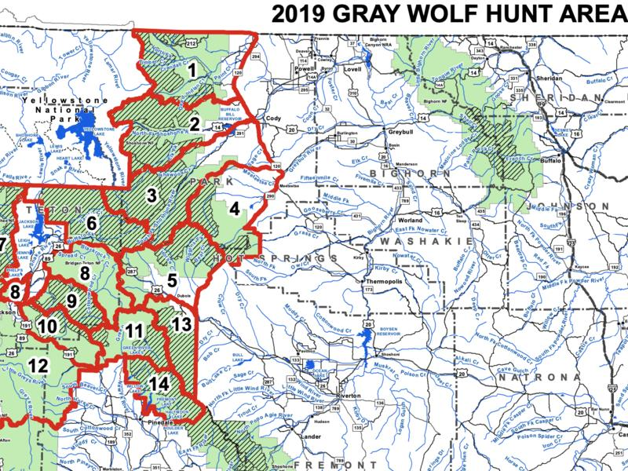
(Mills & Gregory, 2019)
Figure 2
Mule Deer Migrations Eastern Greater Yellowstone Ecosystem
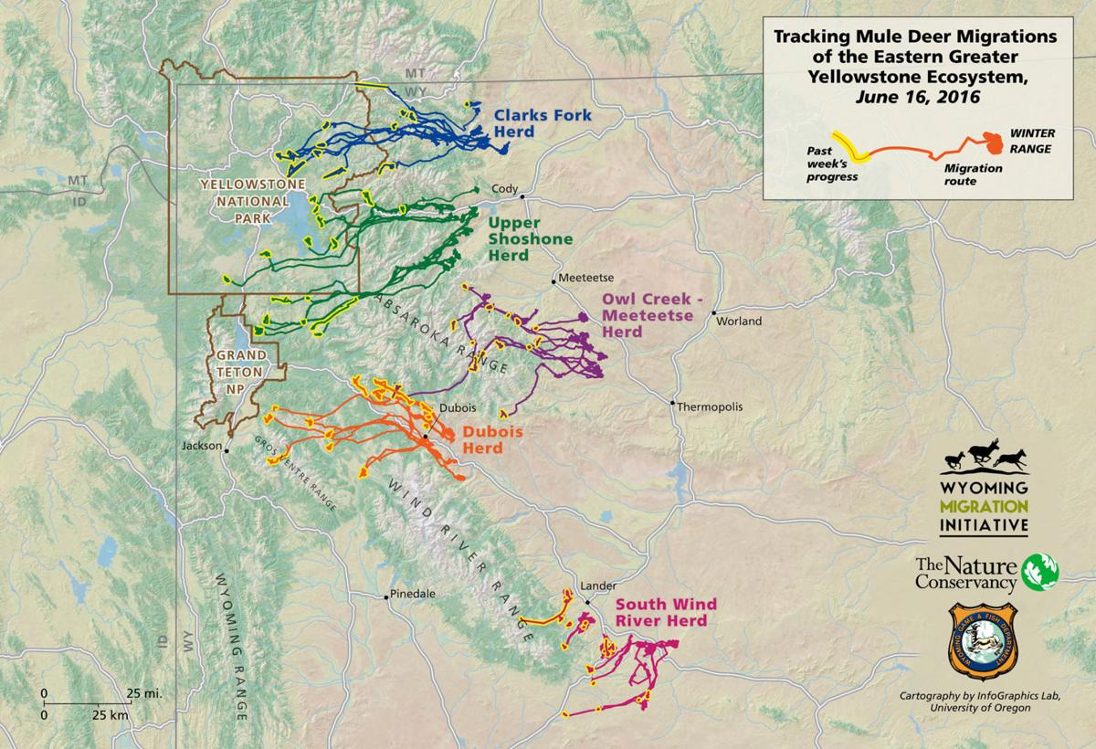
(University of Wyoming, 2016)

Figure 3
Elk Migrations Through Wilderness
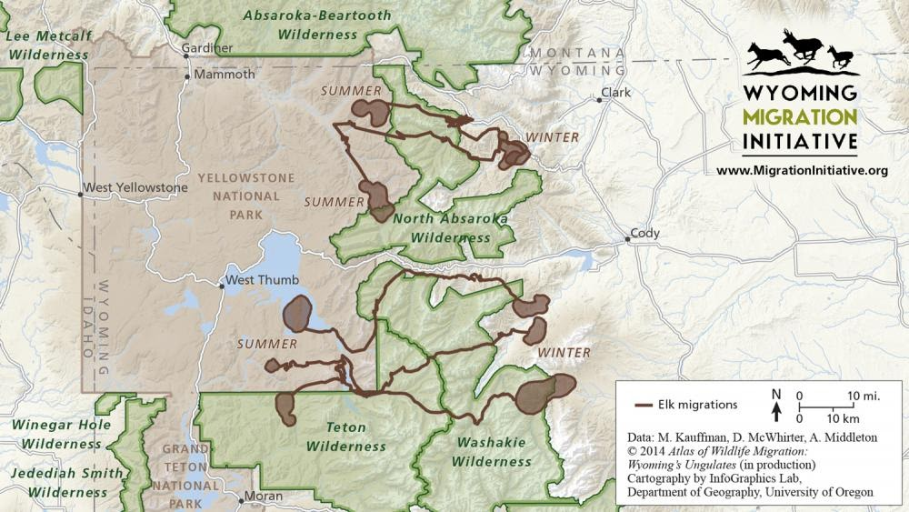
(University of Wyoming, 2014)
Figure 4
CWD Endemic Spread in Elk Hunt Areas
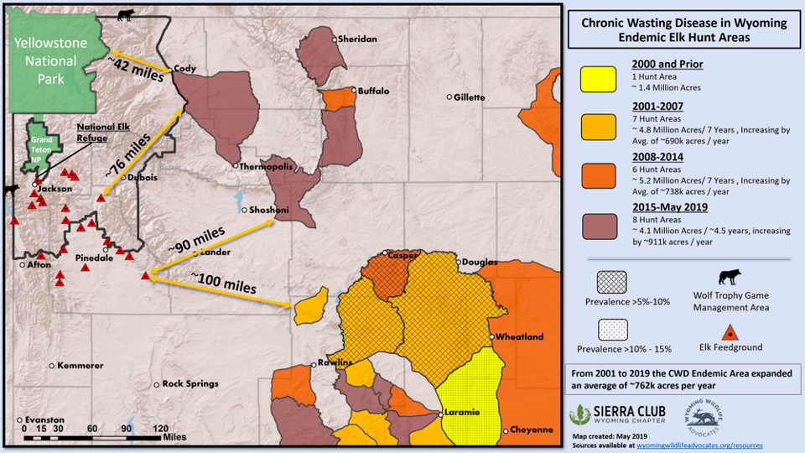
(Sierra Club, 2019)

Figure 5
CWD Endemic Spread in Deer Hunt Areas
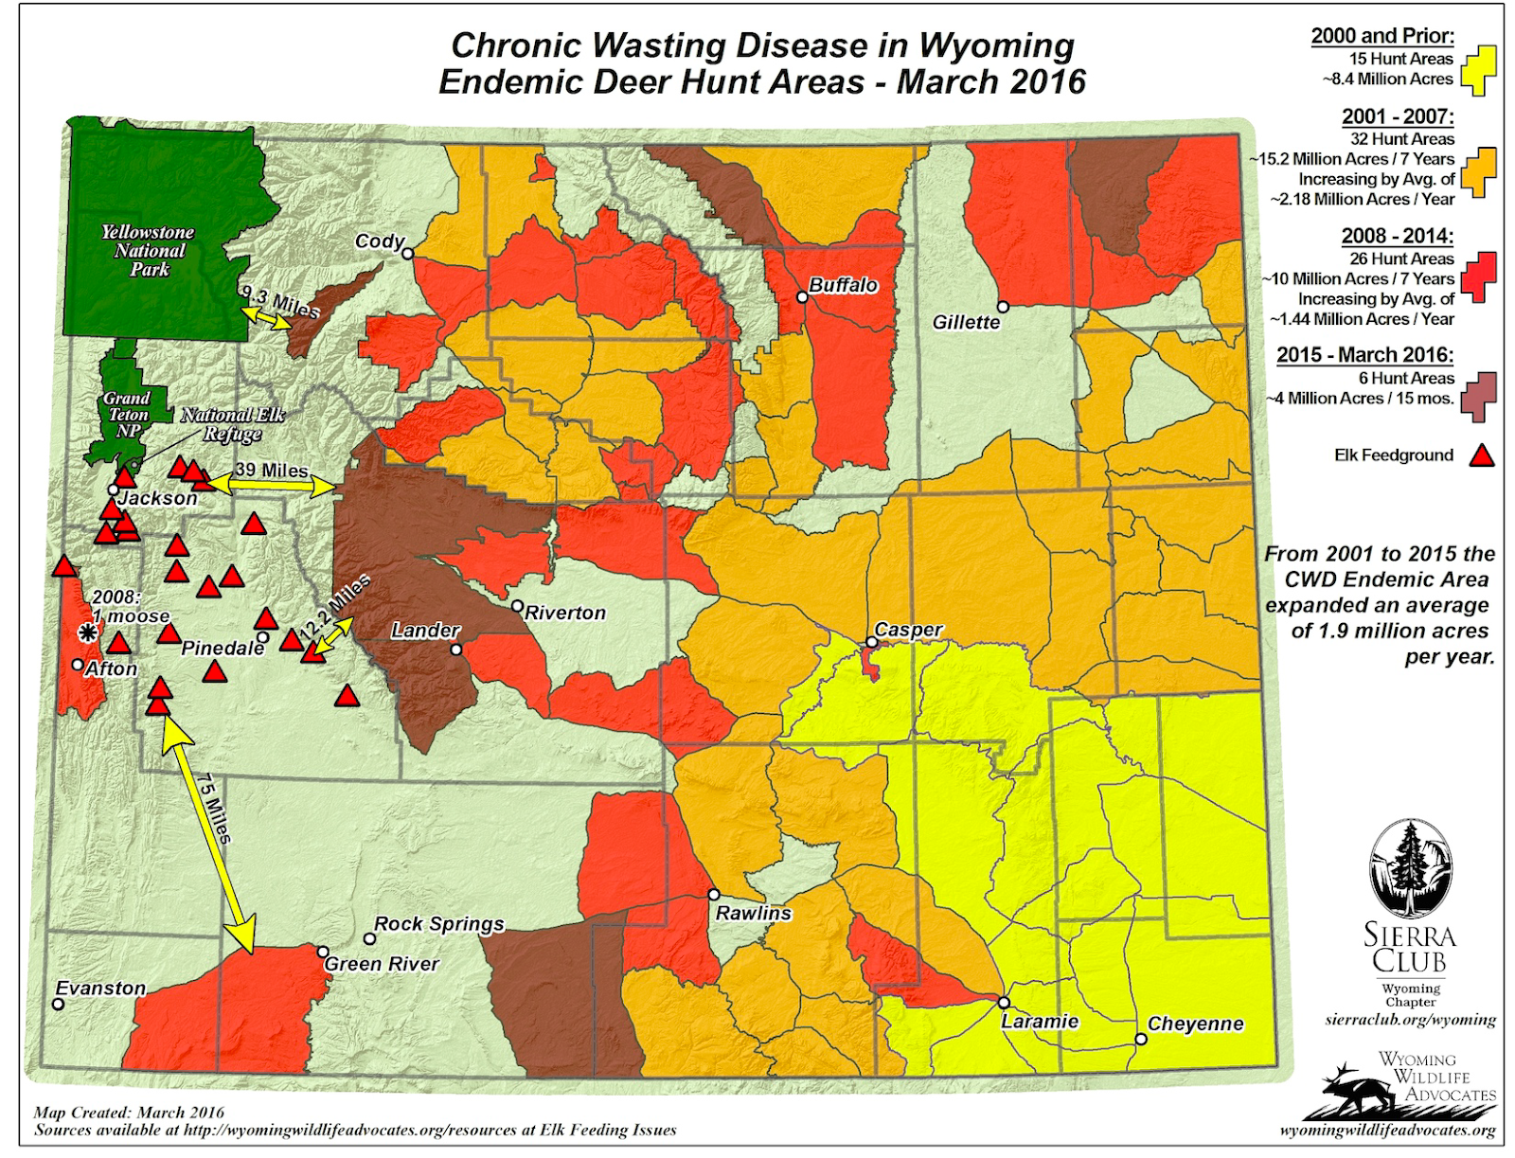
(Sierra Club, 2017)
Figure 6
Wolf Packs in Trophy Hunting Area
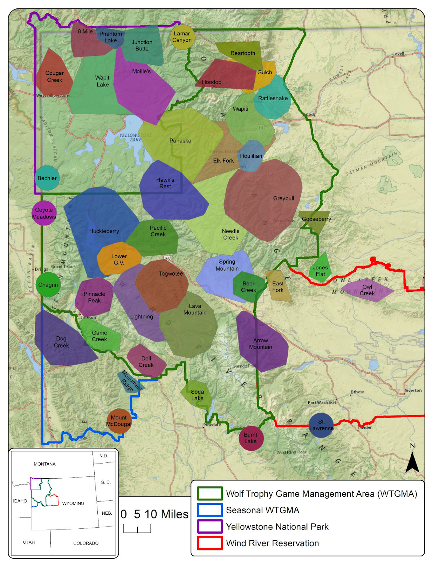
(Mills & Gregory, 2019)

